SQL Server access for Kaggle Competition

Note:

* You can access my SQL Server from most places as long as you are connected to the internet, but the connection might be blocked by company security measure.
* For instance, you **cannot** access my SQL server from Morneau Shepell office if you connect to the internet through Ethernet or MSNET-CERT WIFI. However, you **can** access my SQL Server if you use MSNET WIFI.
* **Last but not least, my SQL Server is connected to my home network. Due to security reason, please do not distribute the access information to non-relevant personnel.**

Remote Access from SQL Server Management Studio

Prerequisites:

* On Windows, Install SQL server Express (as well as Management studio).
* On Ubuntu, a number of software are available, but none of them is as good as the Management studio. I used SQL Connection Studio (Preview) from Microsoft. It is still under development.

From management studio, login as follow:

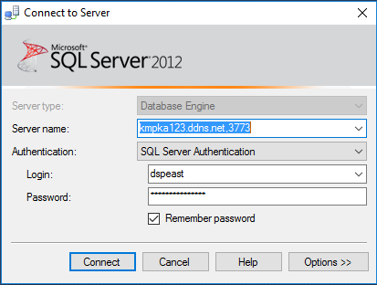

Remote Access from R Script

Prerequisites:

* Install Microsoft SQL server ODBC driver 17

Two ways to connect to SQL server from R

* DSN (Data source name)
* Connection String (I prefer this one as it is more flexible. The following code is based on this method.)

In R script, use the following code to connect to DB:

##

# Two R packages required:

# 1.\ DBI

# 2.\ odbc

##

conn <- DBI::dbConnect(drv = odbc::odbc(),

Driver = "ODBC Driver 17 for SQL Server",

Server = srv, # Replace it with the server name from email

Database = “HomeLoanDefaultRisk”,

UID = uid, # Replace it with the user name from email

PWD = pwd) # Replace it with the password from email

Please see the attached R script file for amber of useful functions.